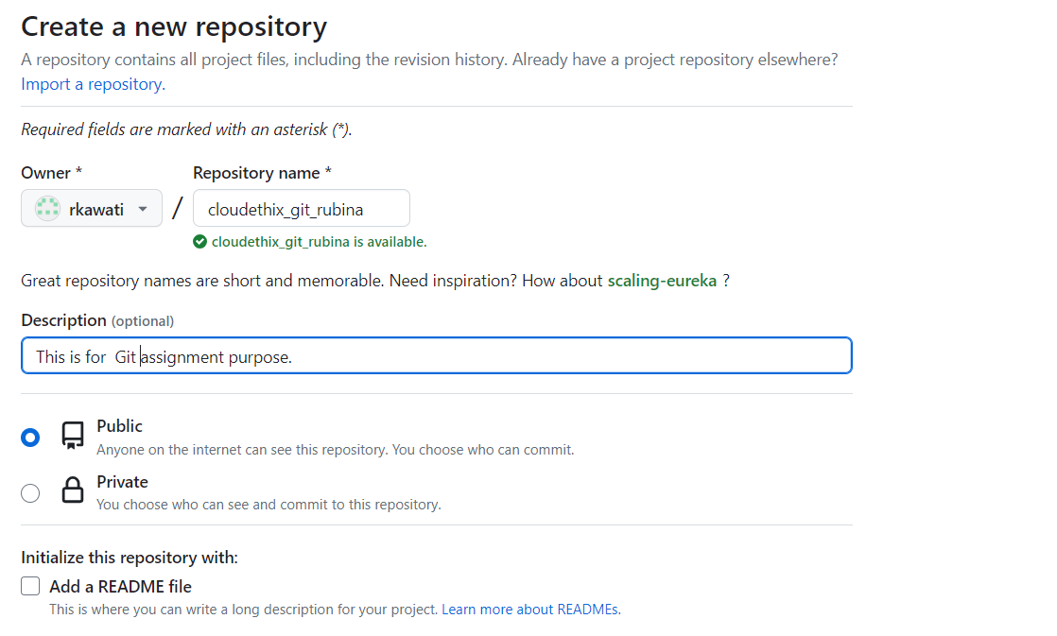

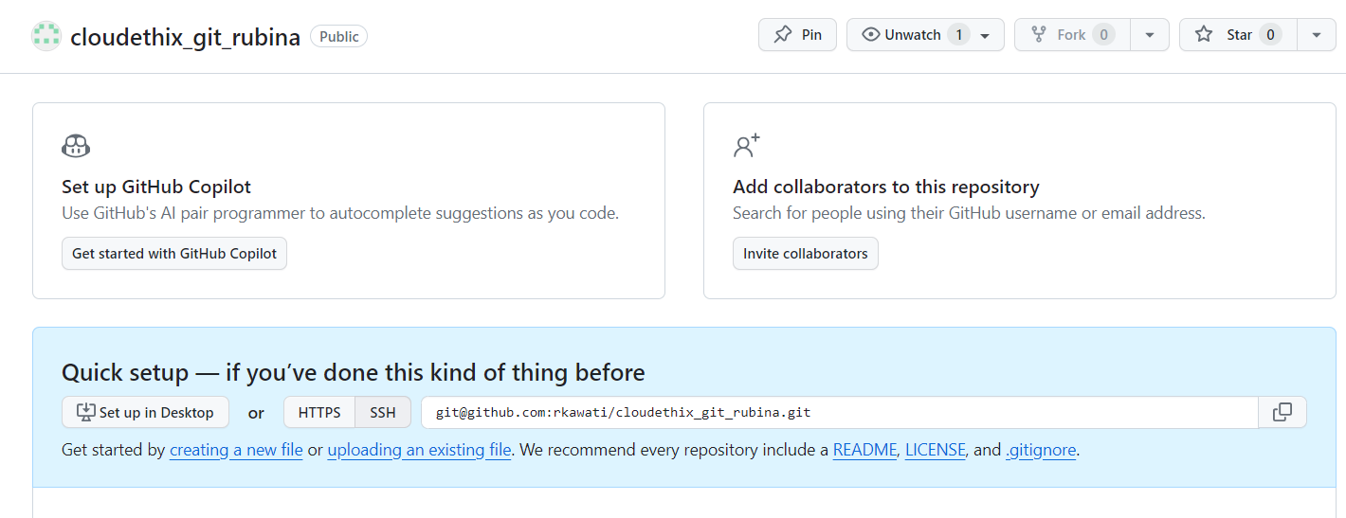

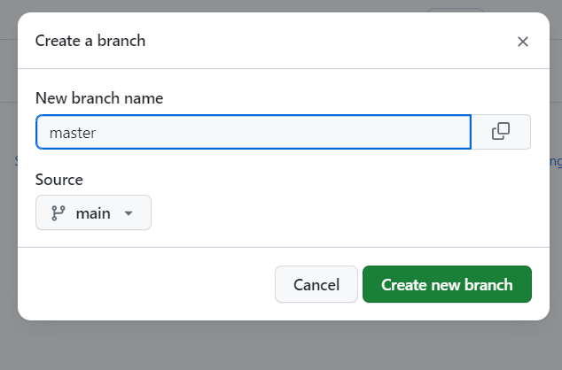

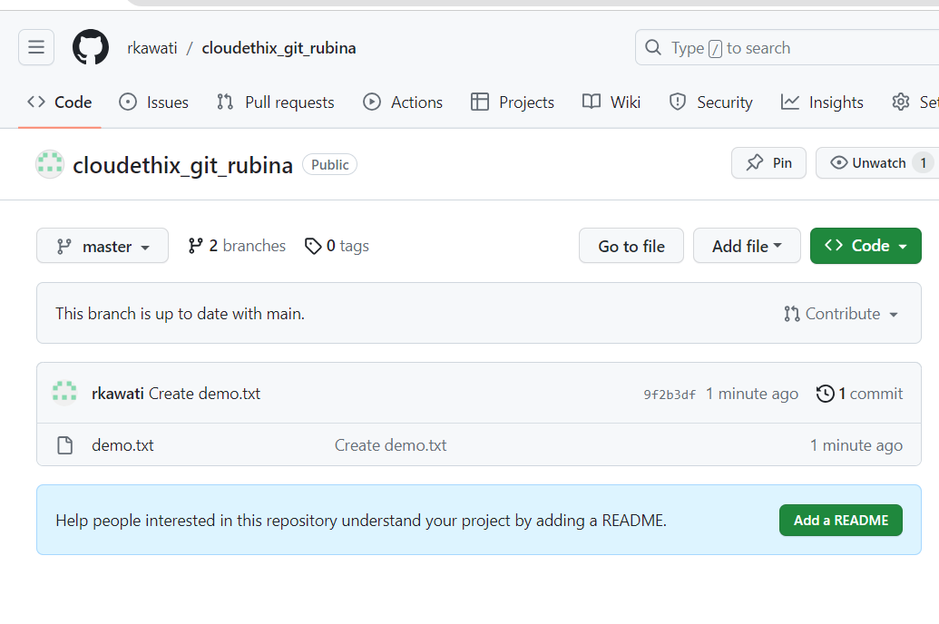 

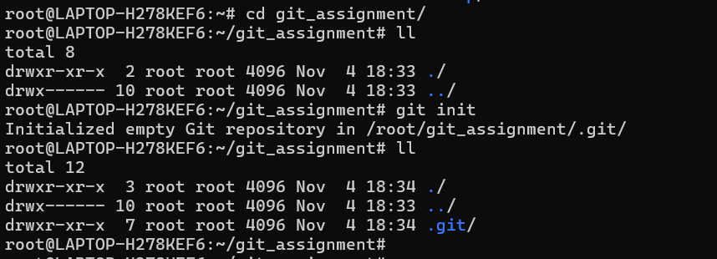

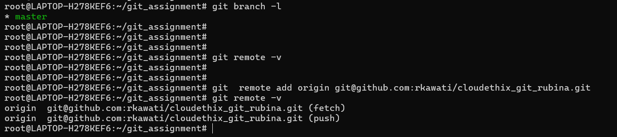

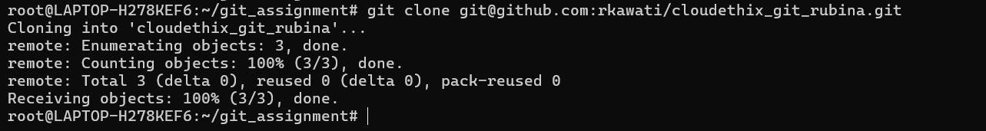

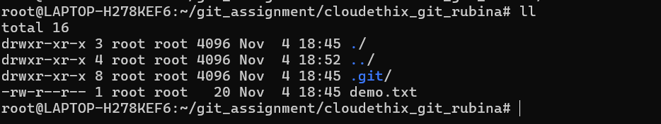

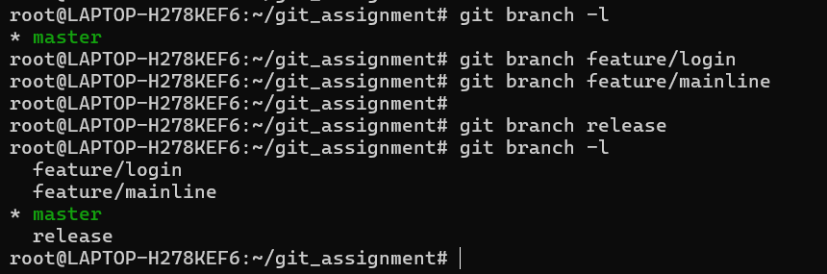



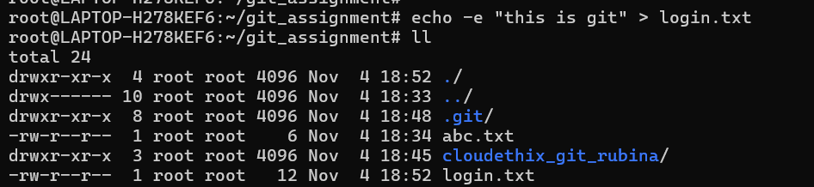

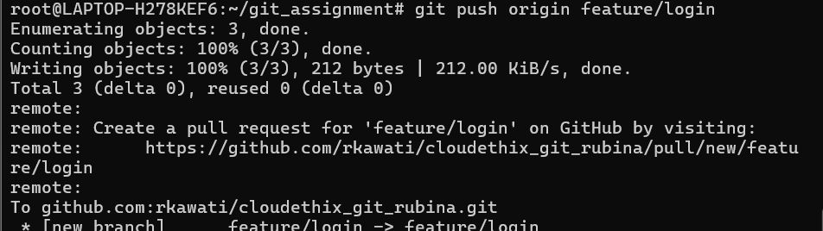

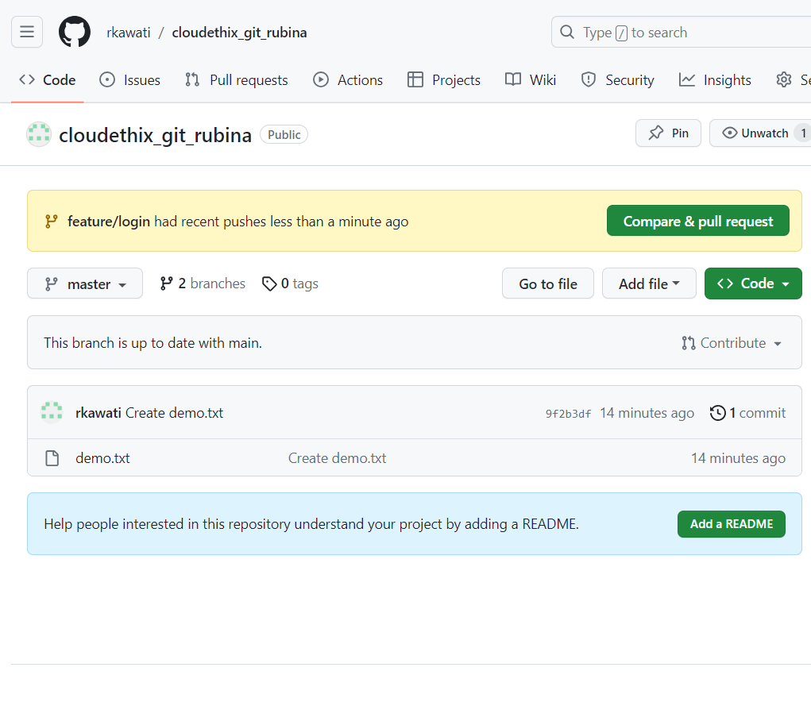

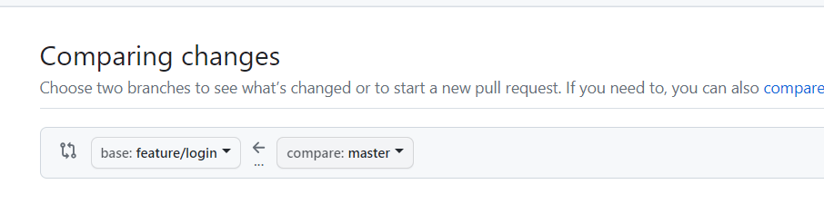

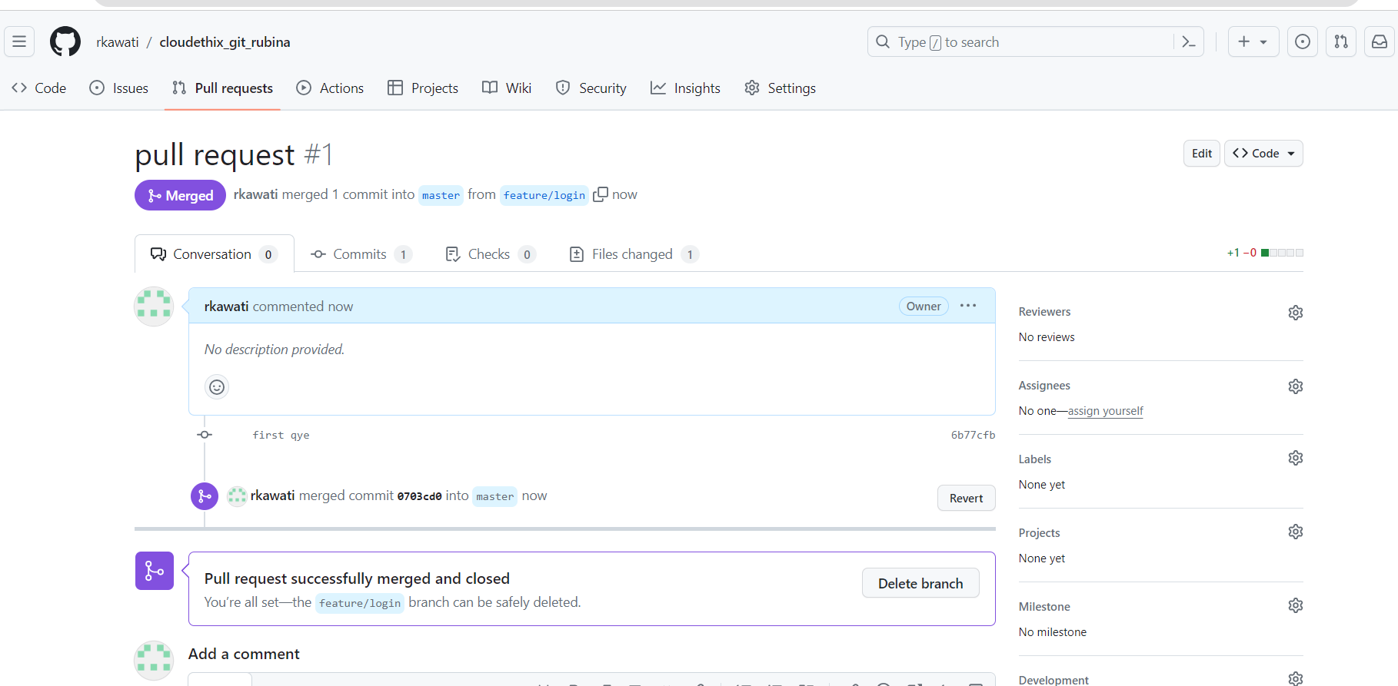

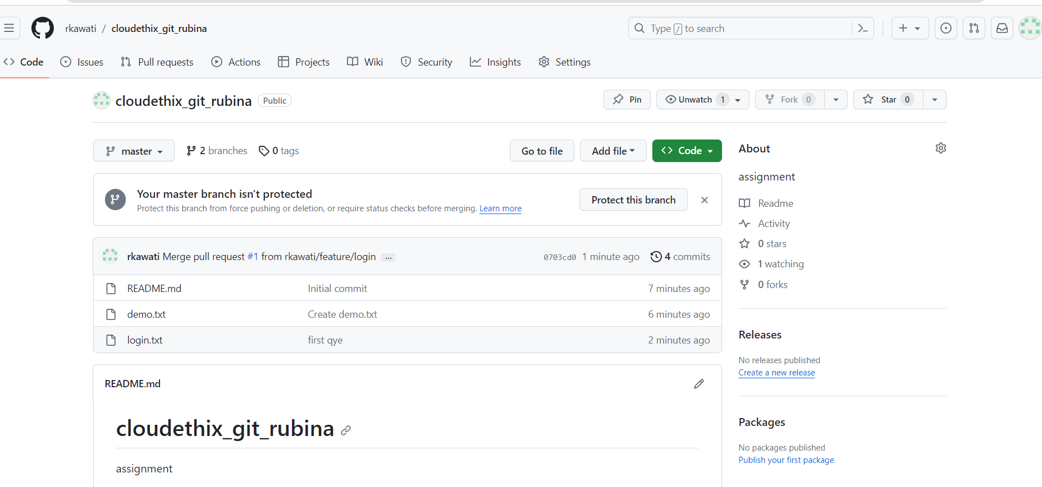

Q.2 Add files to the feature/mainline branch to local repo and push that branch to

remote. Then add some files to the feature/mainline remote branch from the UI.

Then fetch the latest changes on local feature/mainline with Fetch and Pull

command.

Solution=

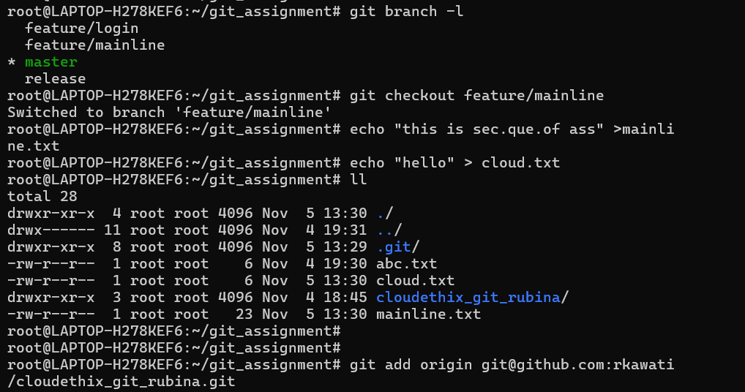

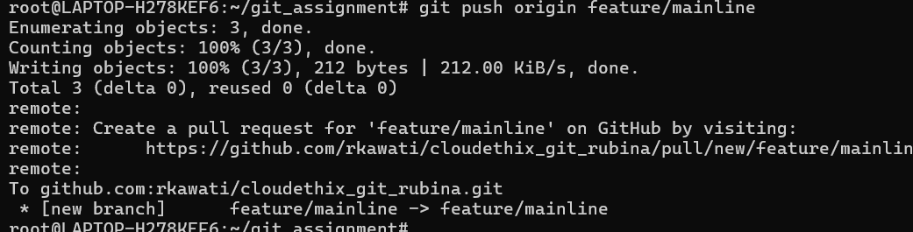

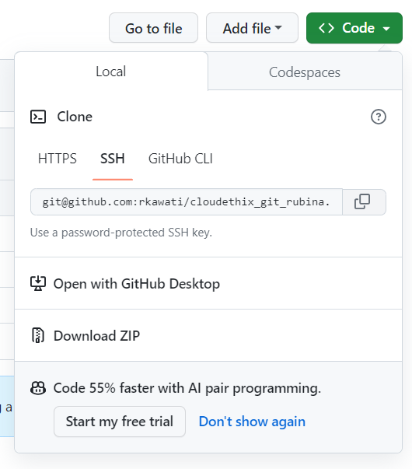

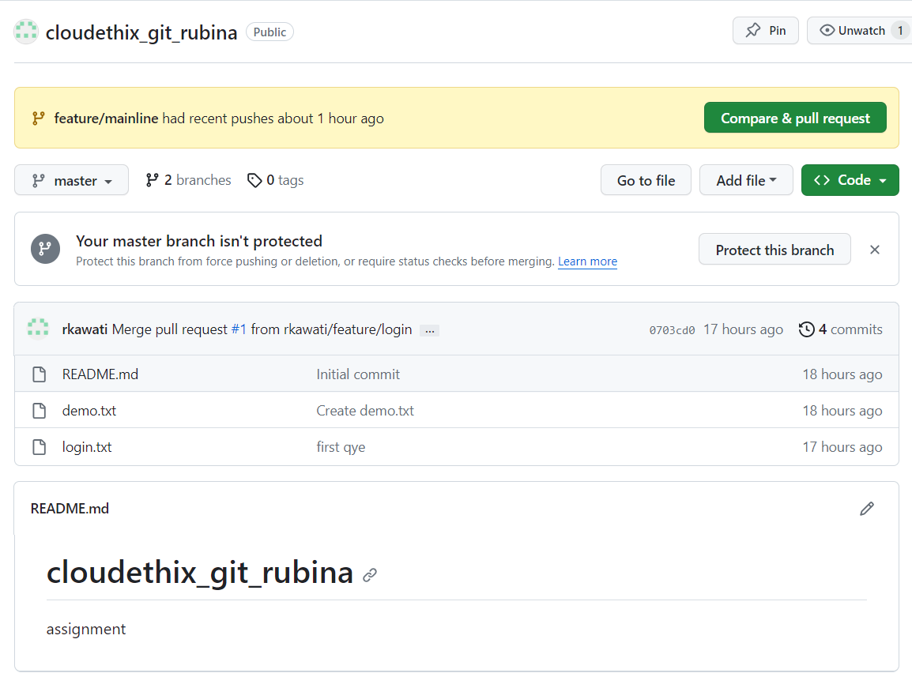

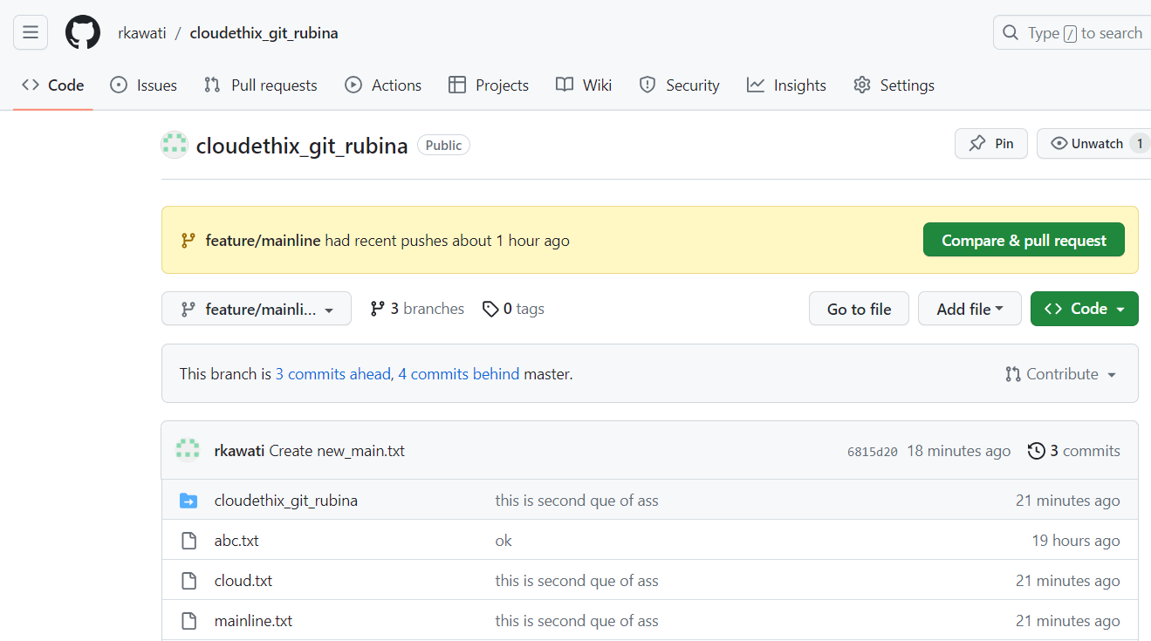

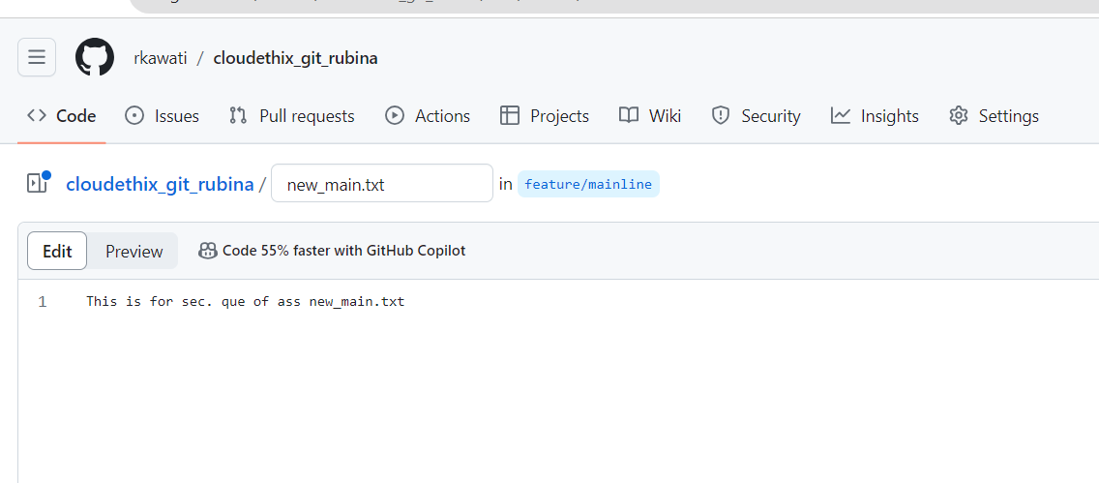

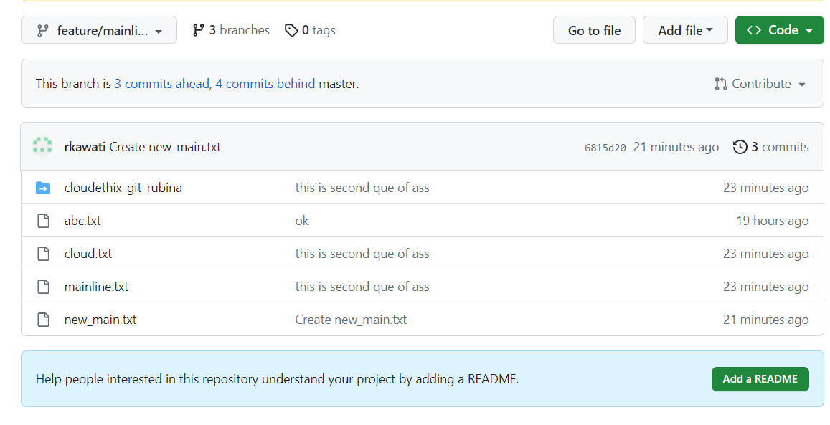

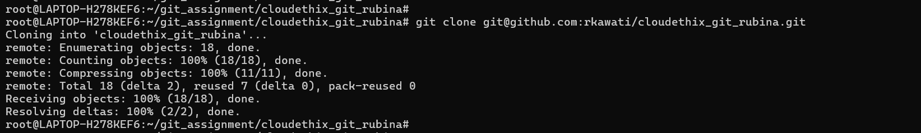

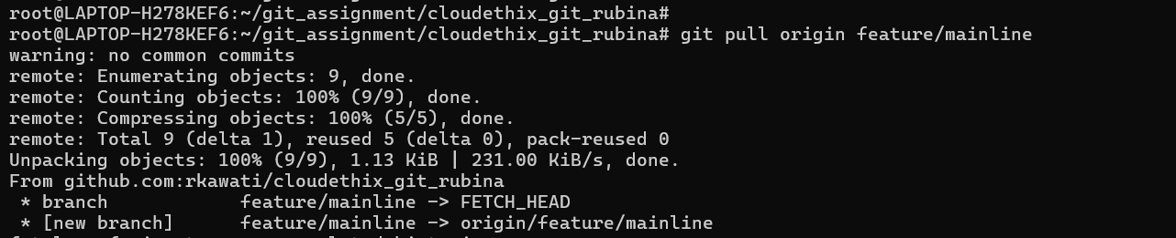

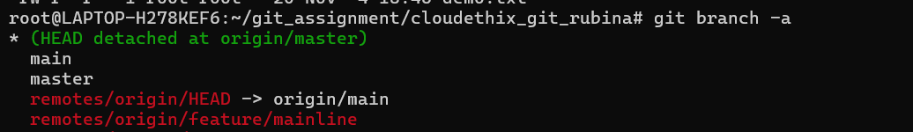

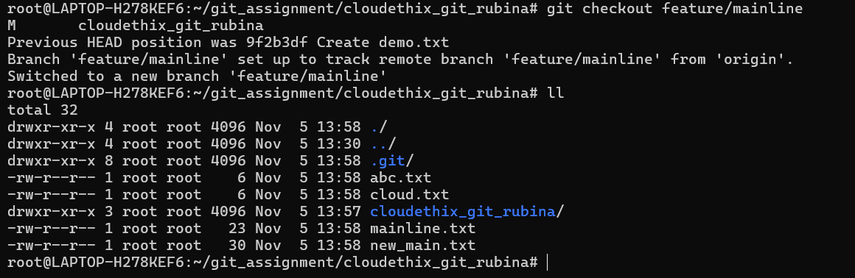

3. Fork below public repository to your account. Then clone the repository locally.

Create 2 branches cloud_dev01. Then add cloud_dev02 to that repository locally

and hello.txt , moto.txt and world.txt to one branch and add another 3 files to

another branch. Then push cloud_dev02 branch to the Forked repository on the

remote.

https://github.com/ripienaar/free-for-dev

Solution==

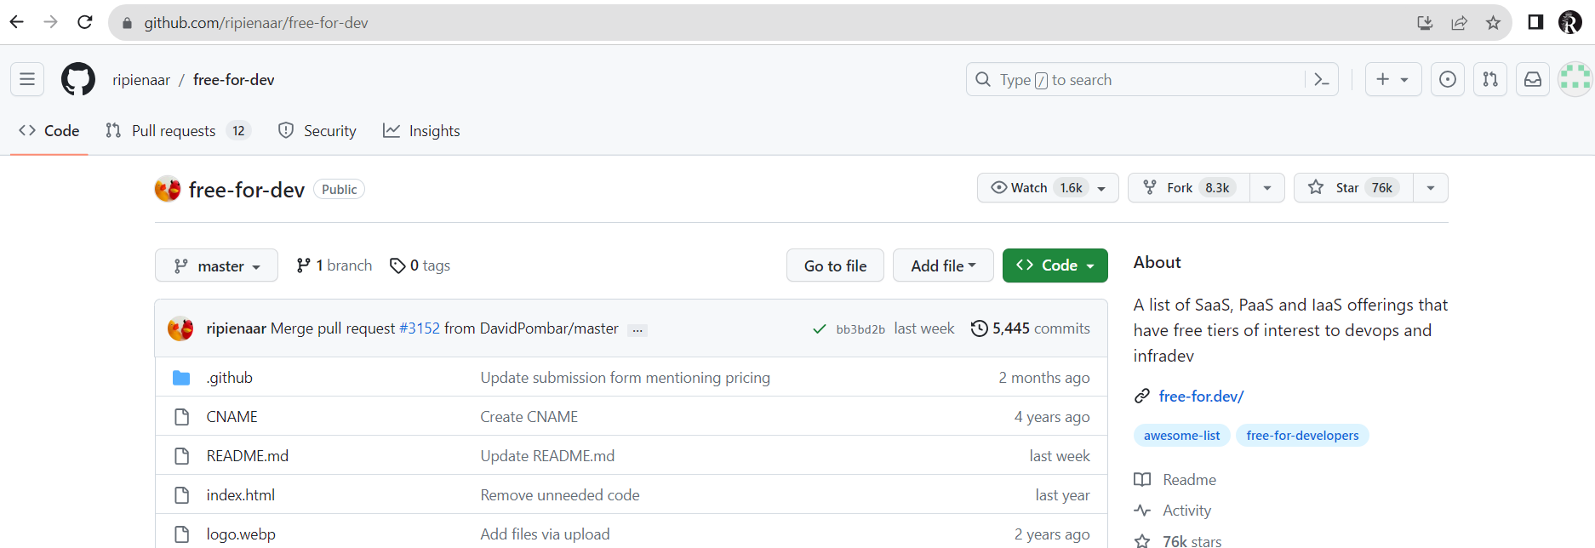

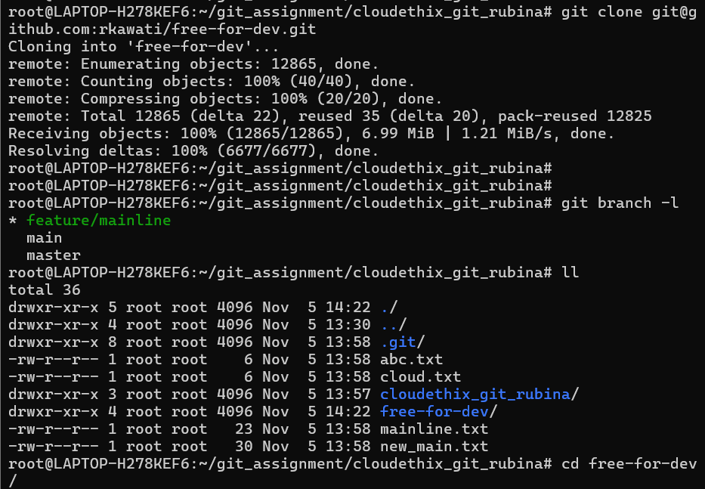

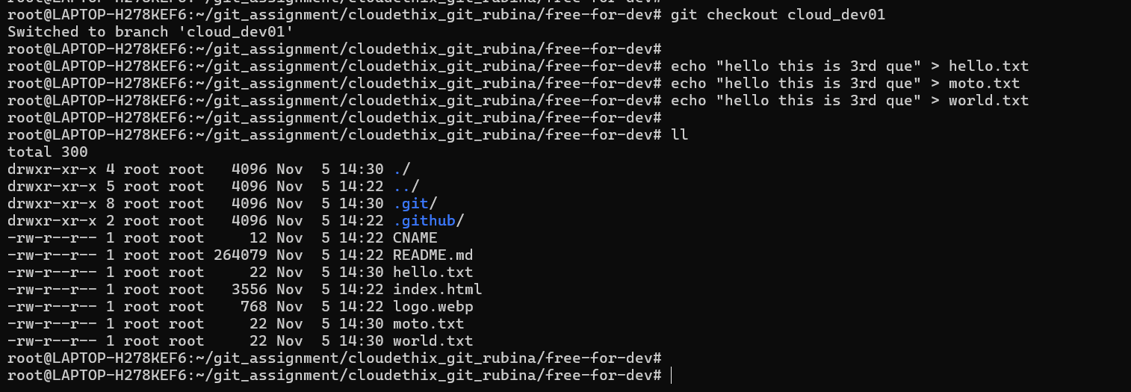

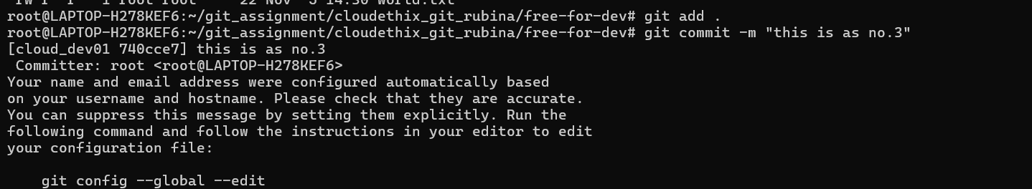

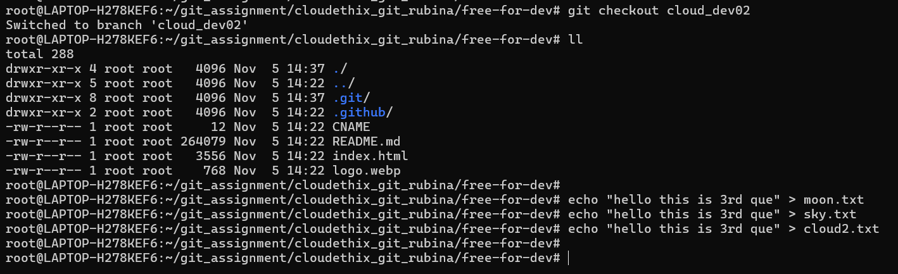

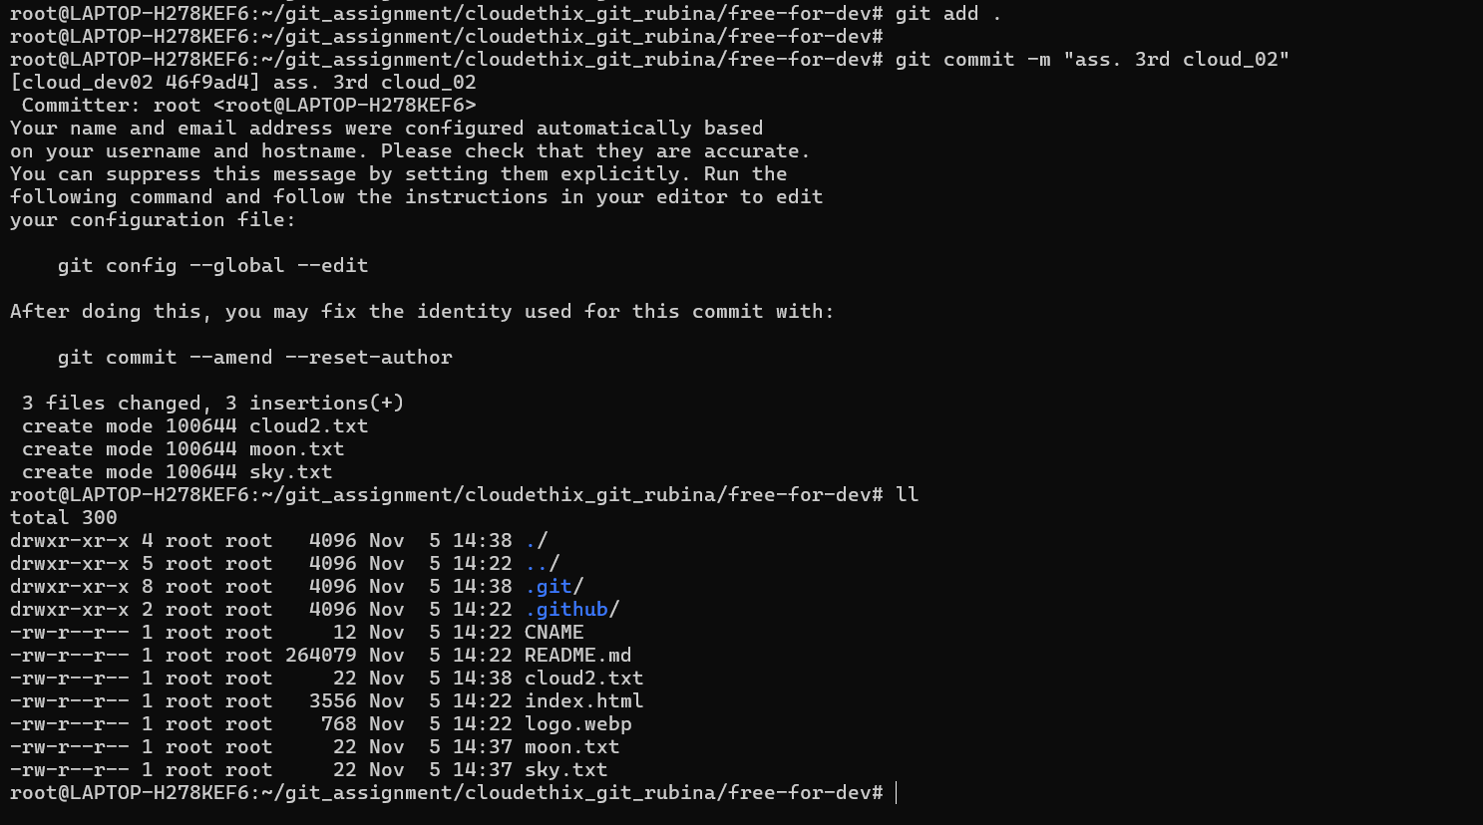

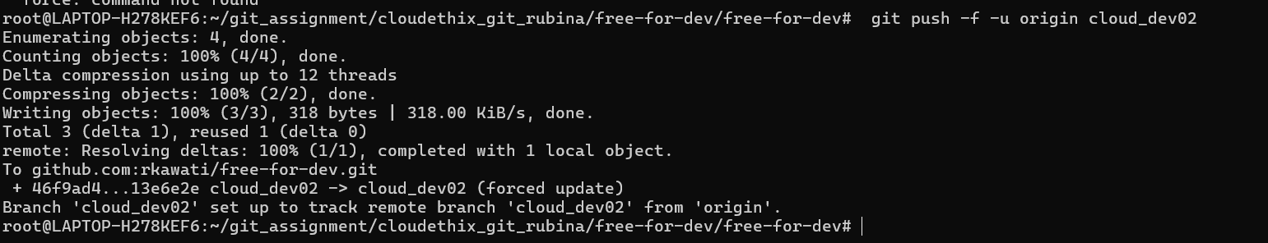

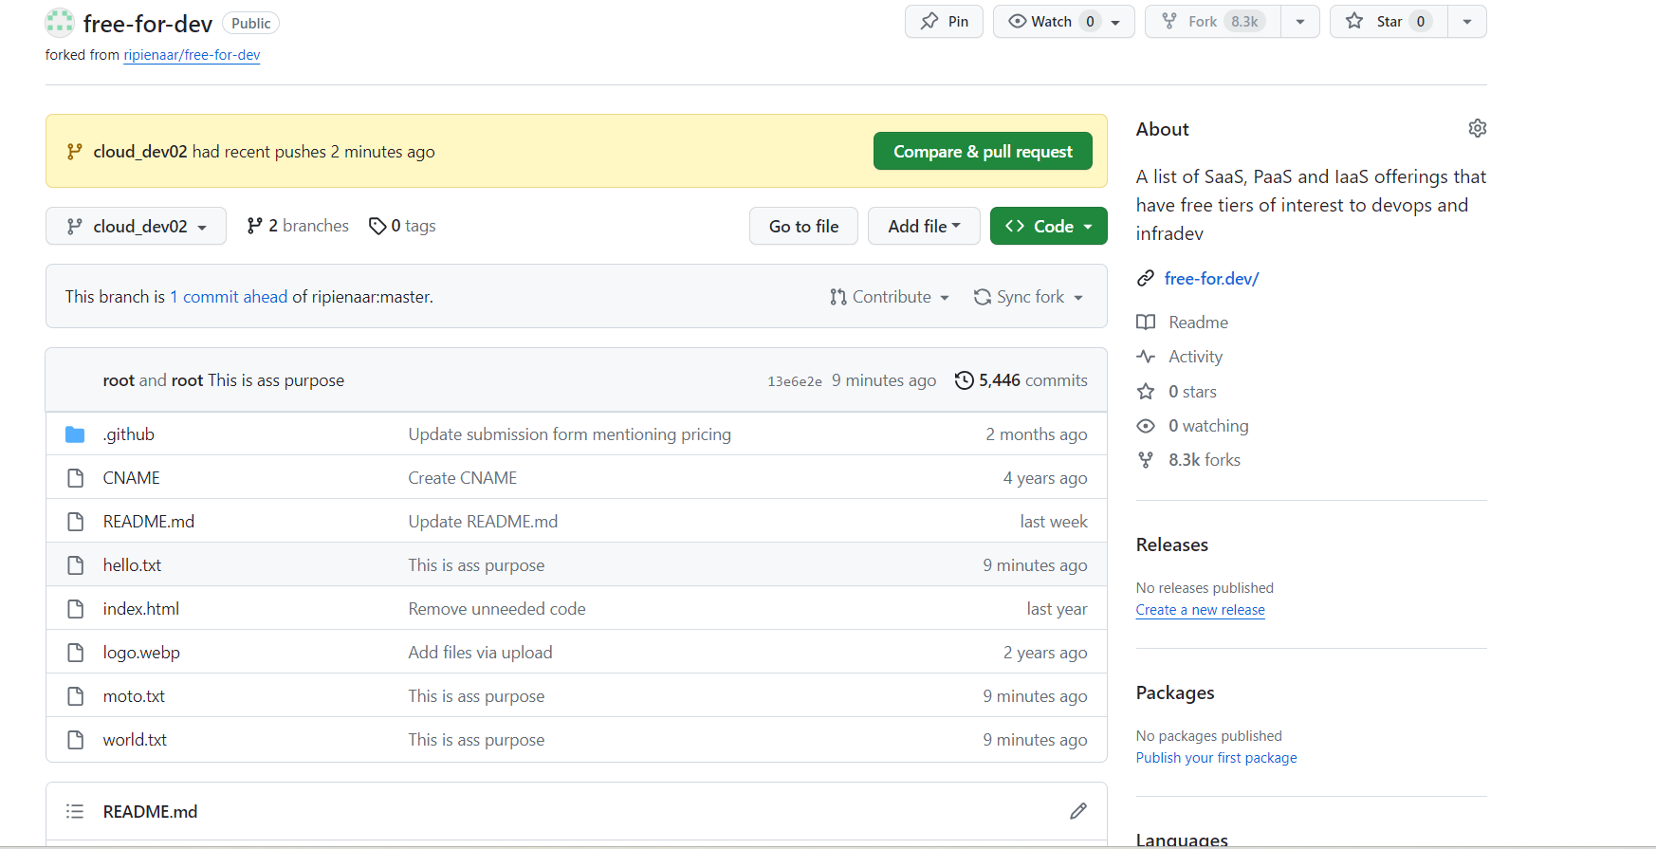

4. Create a remote repository merge_confilct_demo. Add some files in the remote

master branch. Clone the repository locally. Create 2 branches locally named

demo/merge and demo/conflicts. Add a merge.txt file in both branches with some

data like "Hello CloudEthiX…." And "Fello CloudEthiX…." respectively and

commit. Then merge demo/conflicts branch to demo/merge branch and solve the

merge conflicts.

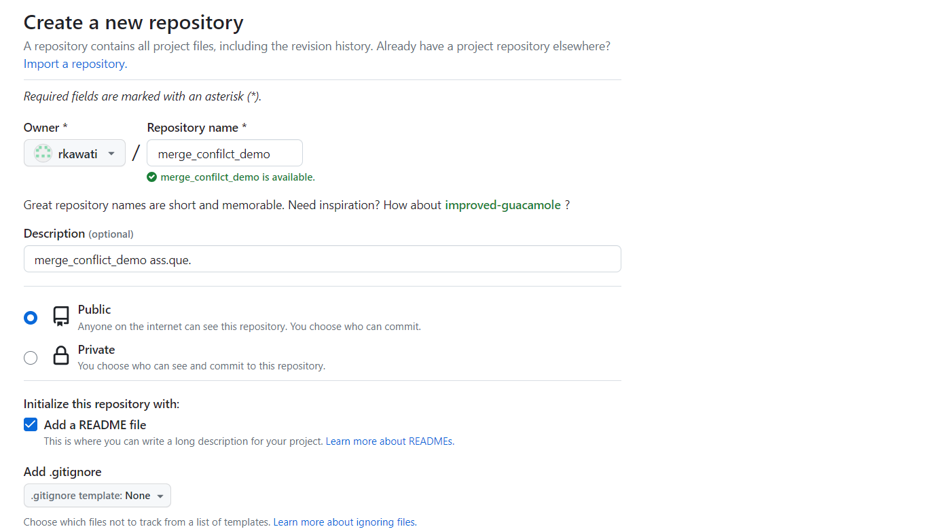

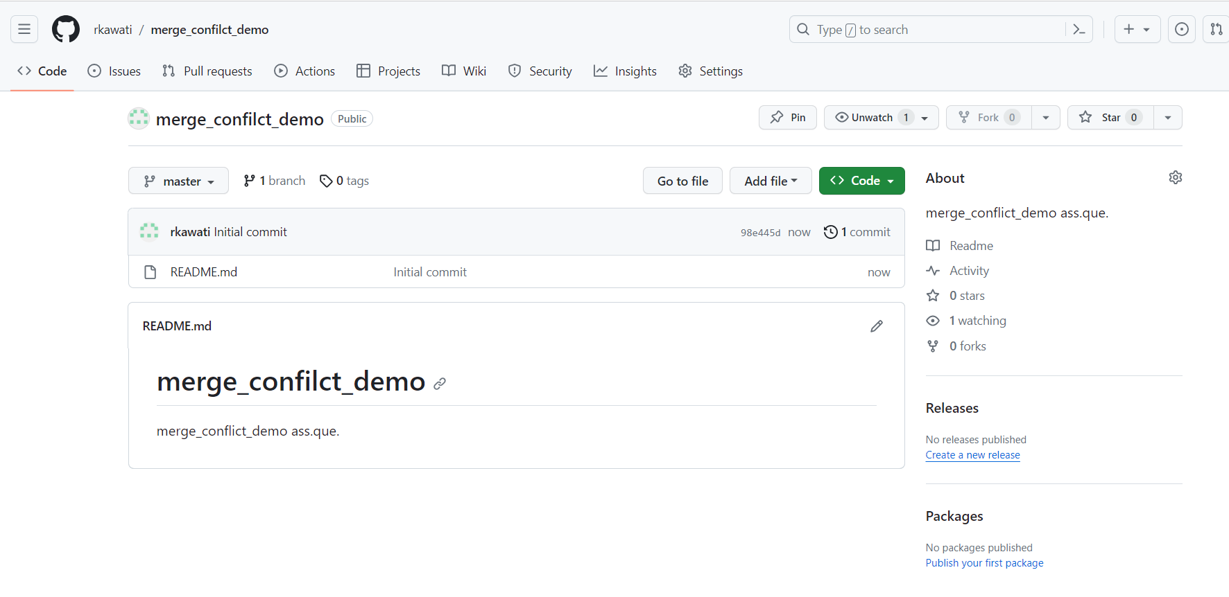

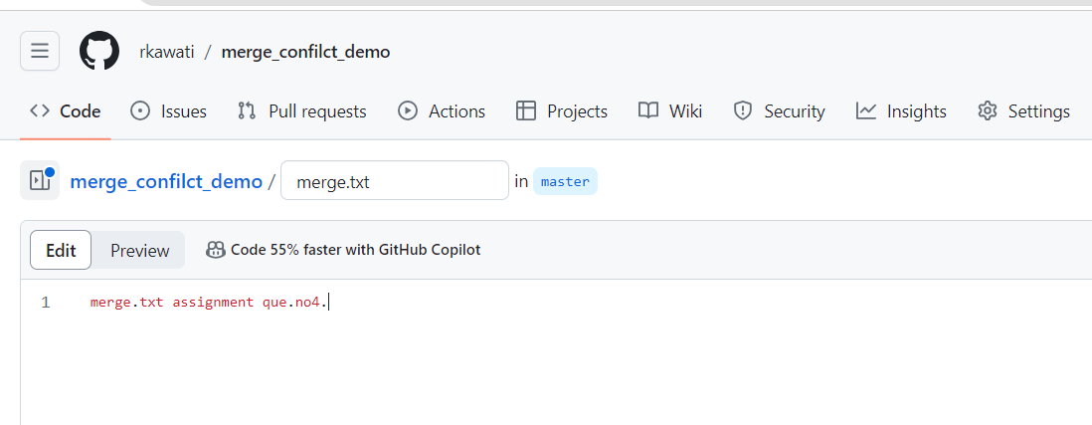

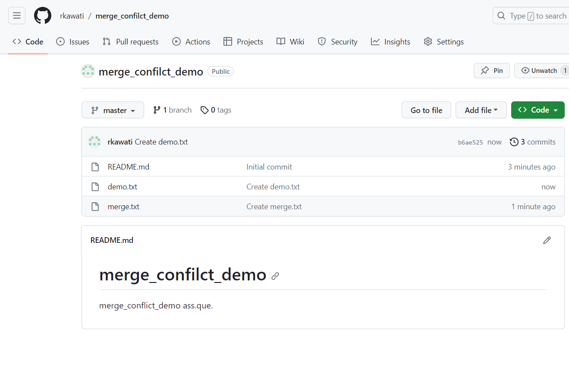

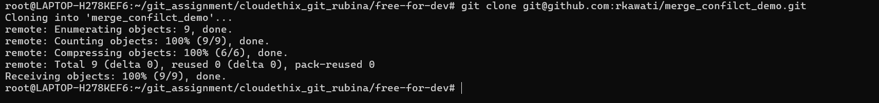

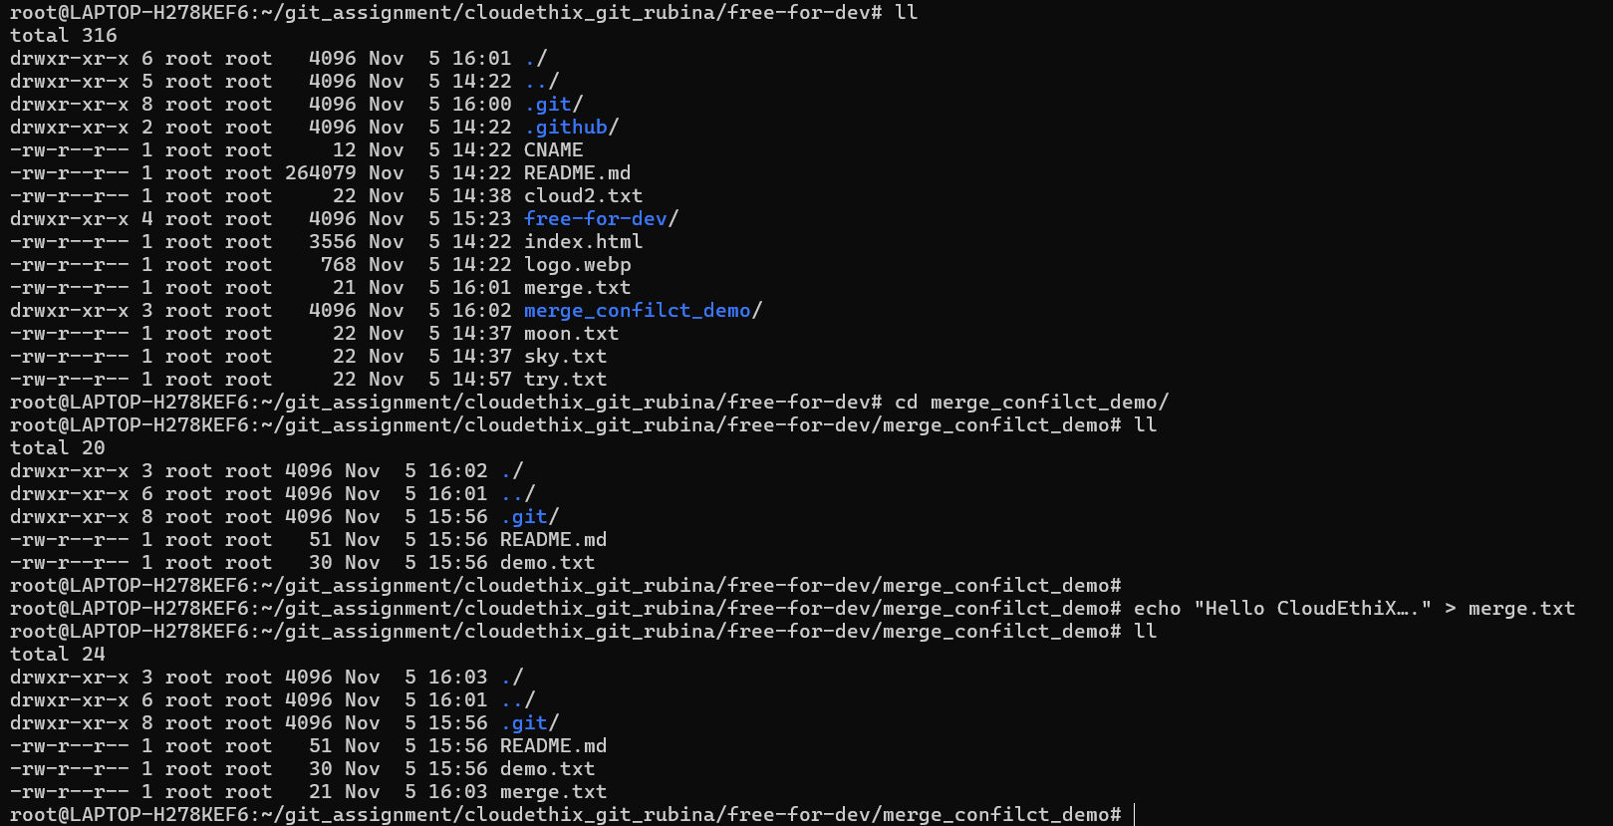

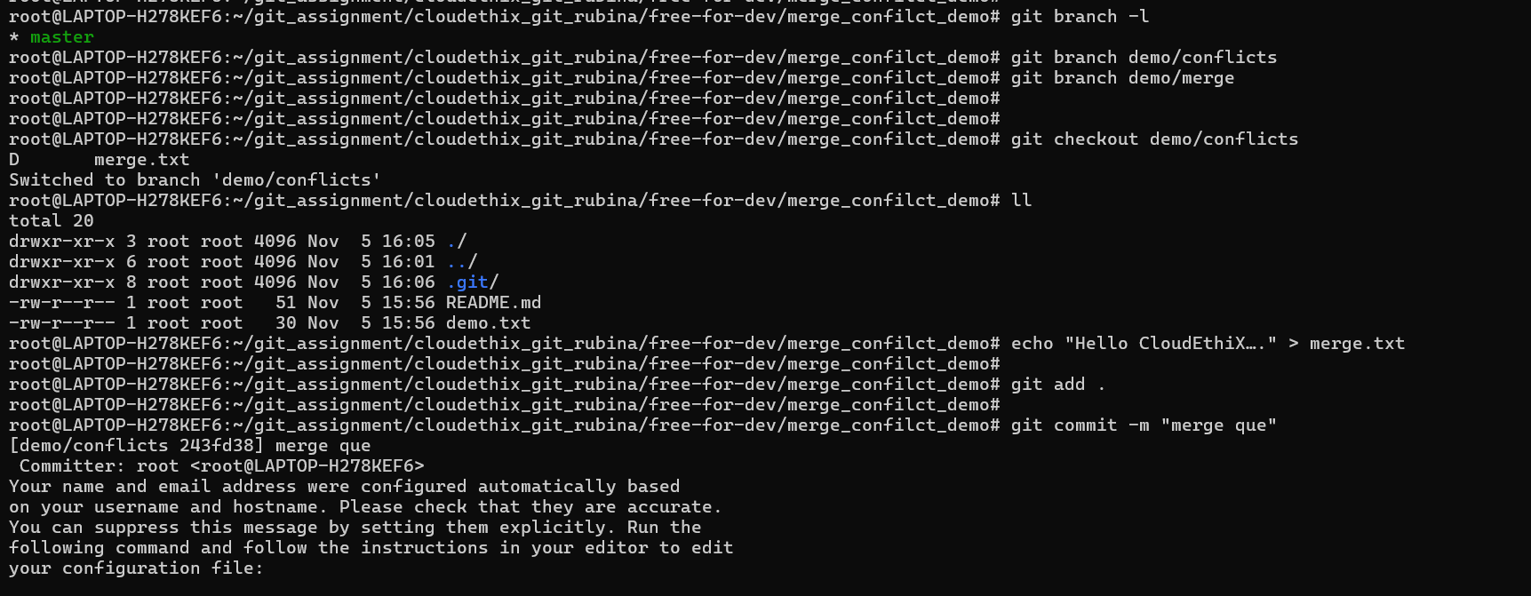

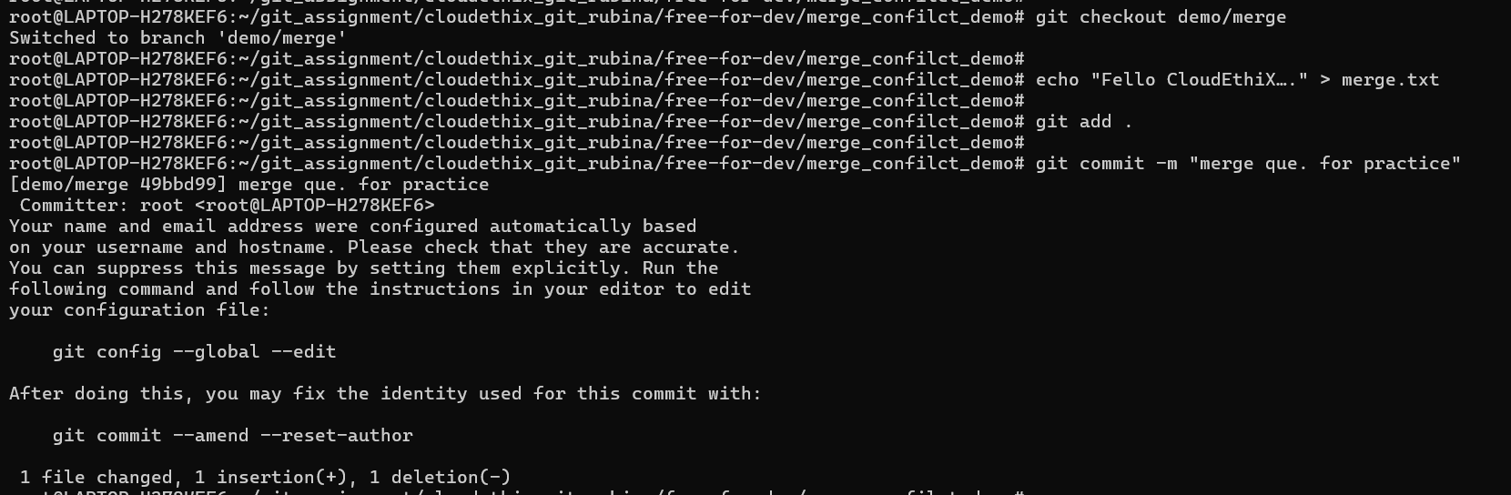



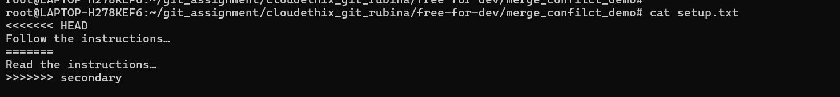

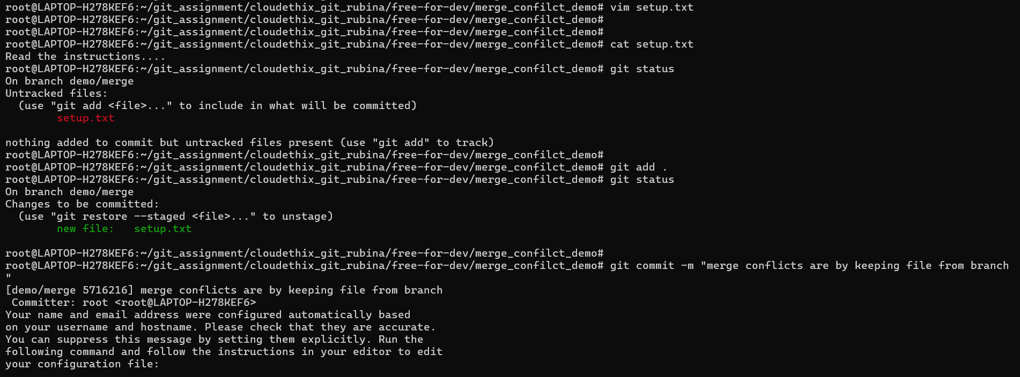

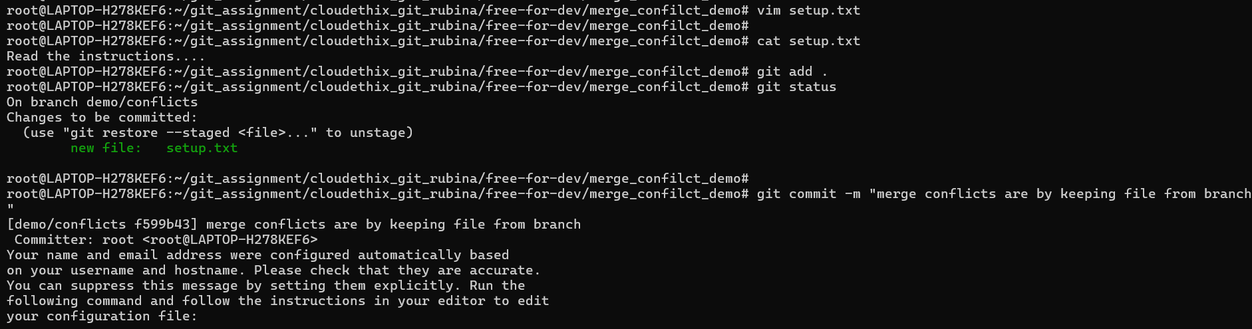

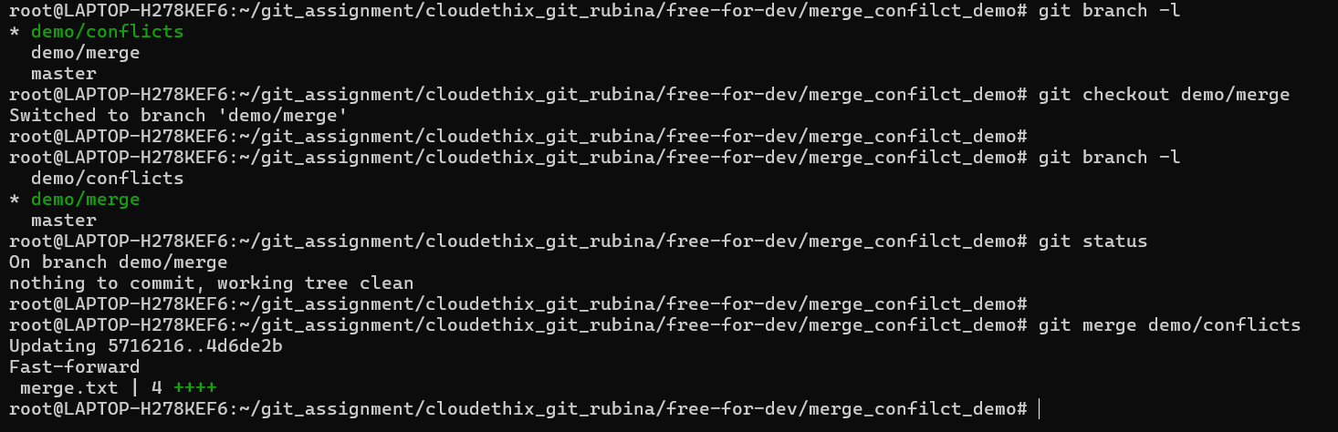

==================================================================================

5. Create PR to merge the cloud_dev02 branch to Forked repository. Approve the PR and

merge cloud_dev02 branch to master branch remotely.

Solution=

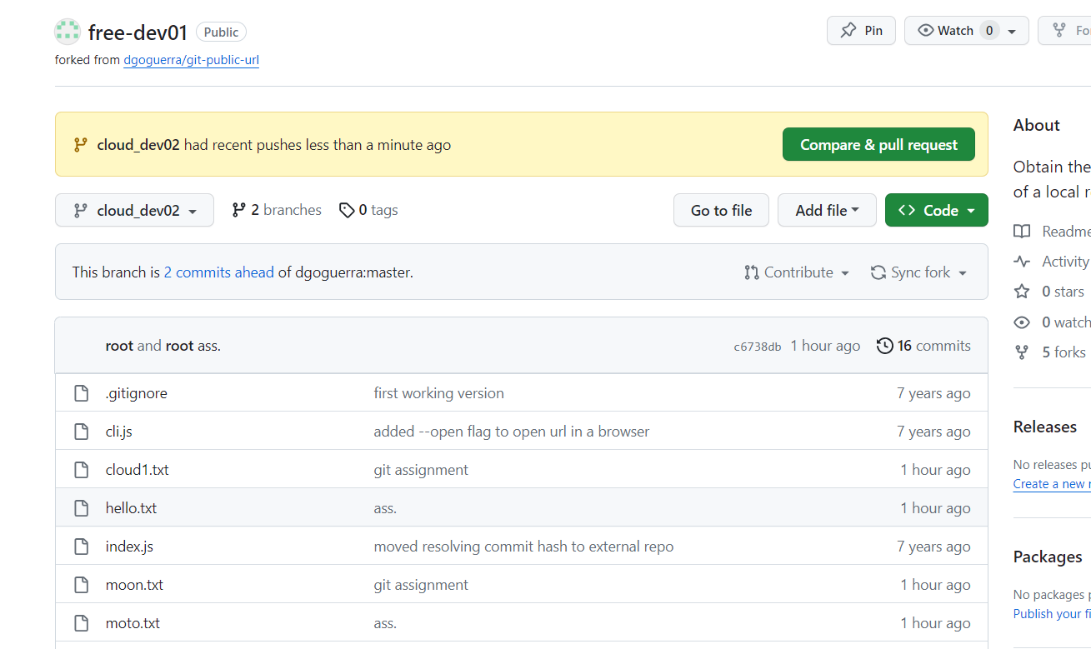

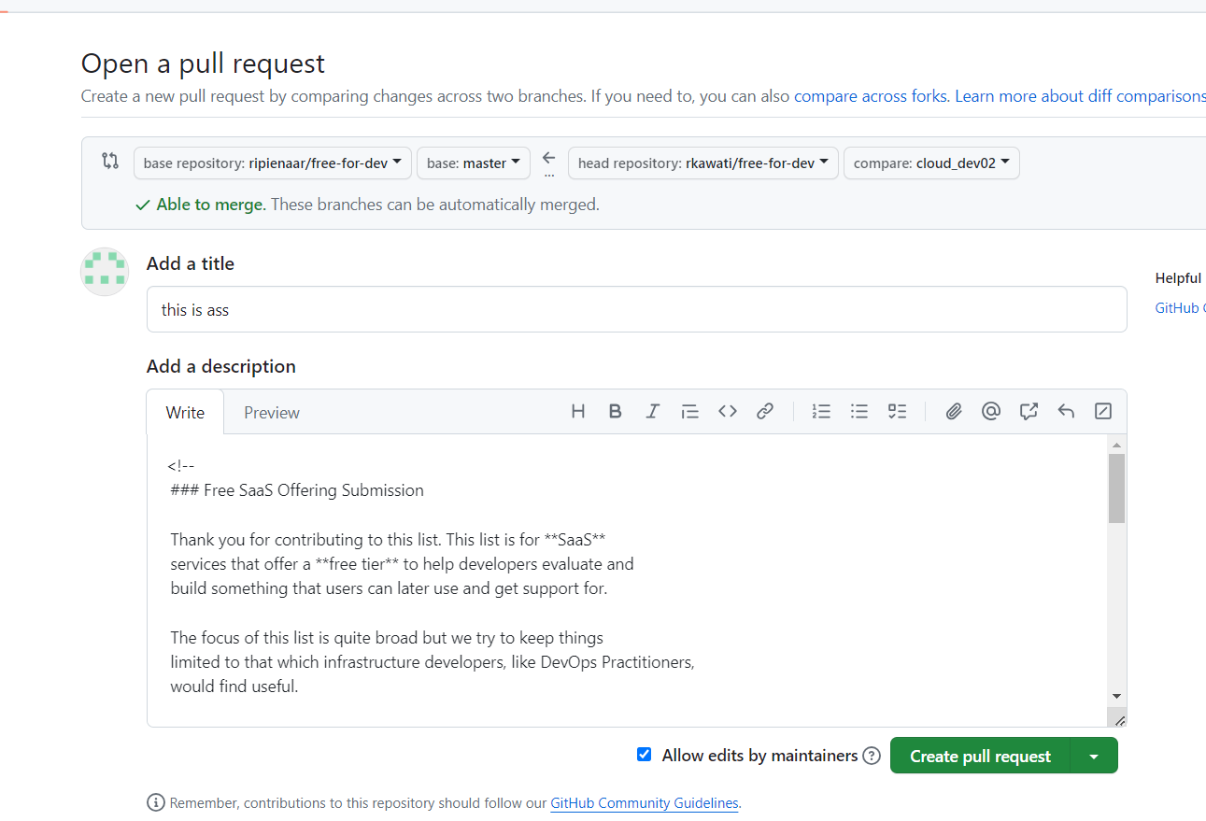

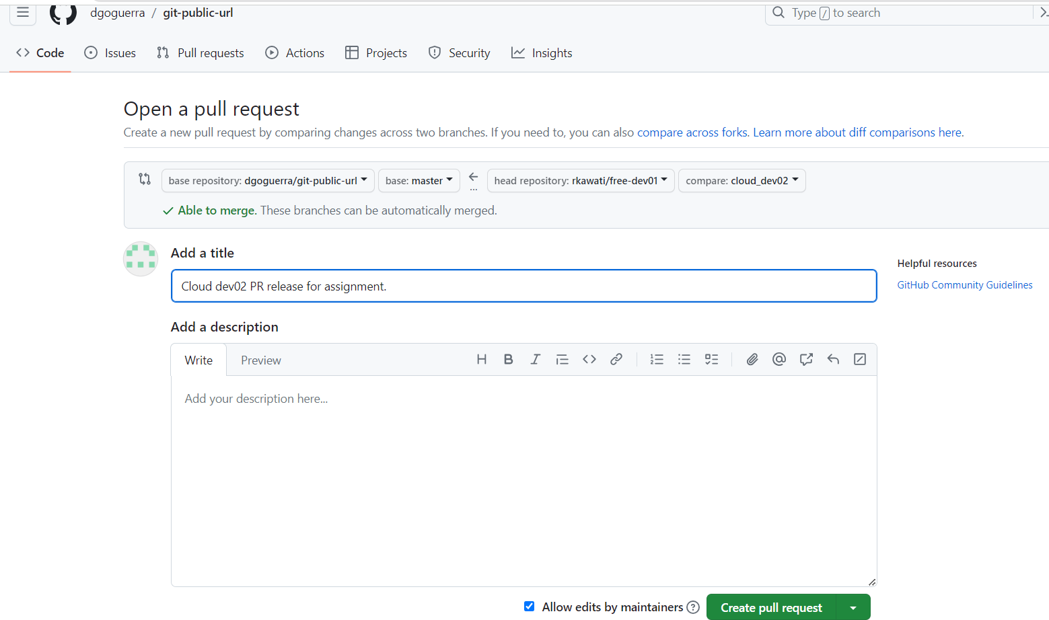

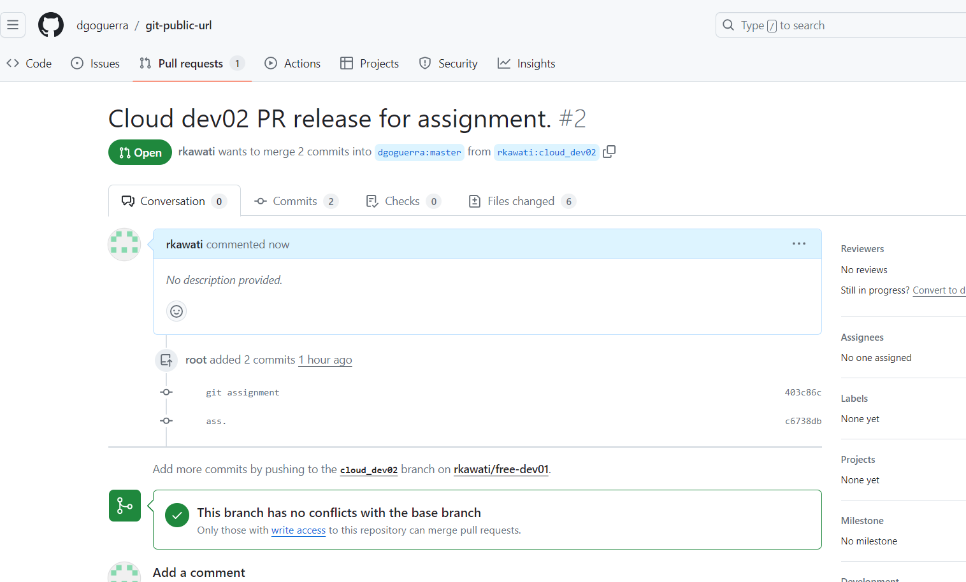

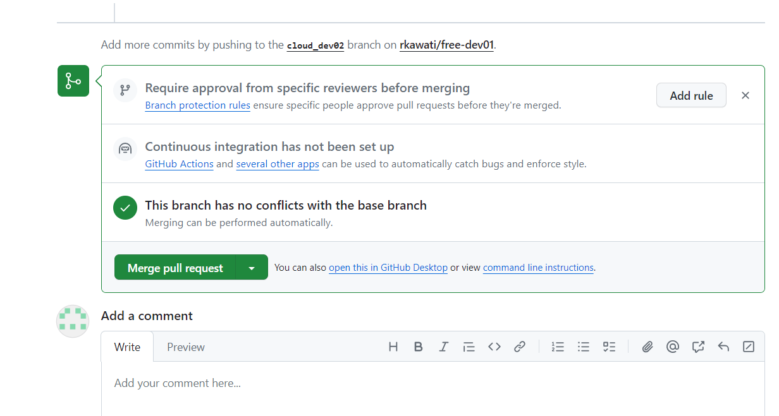

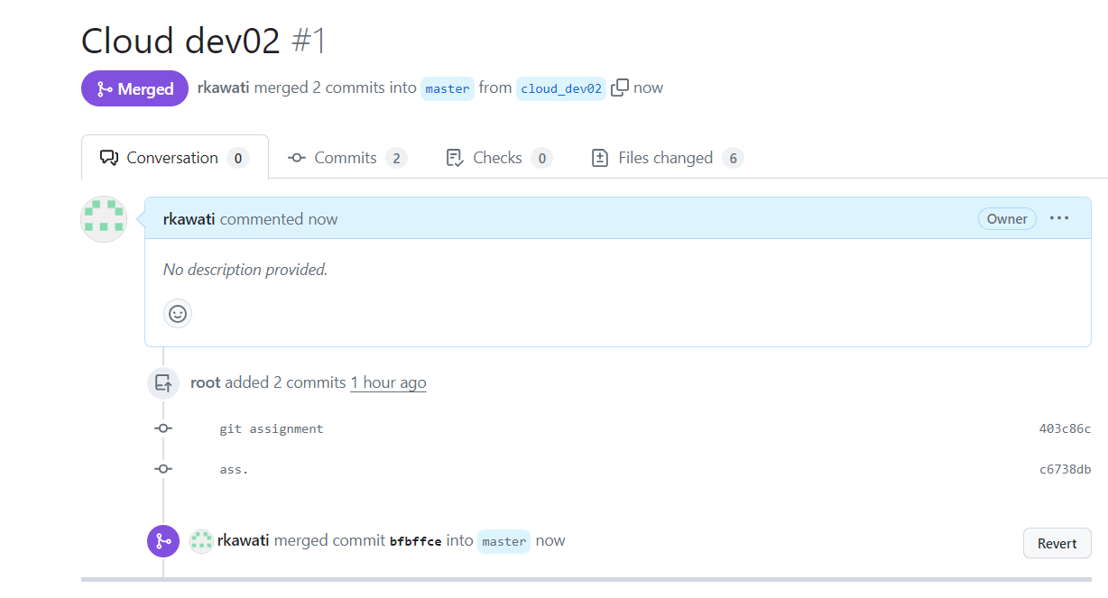

6. Fetch latest changes from master branch of remote forked repository to local

master branch. Then merge forked remote master branch with local master

branch. Check If all the latest files are there. Then checkout to local cloud_dev03

branch locally. Then Pull latest changes from the remote master branch.

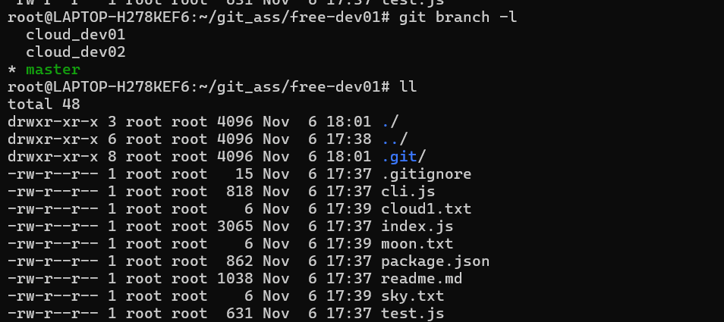

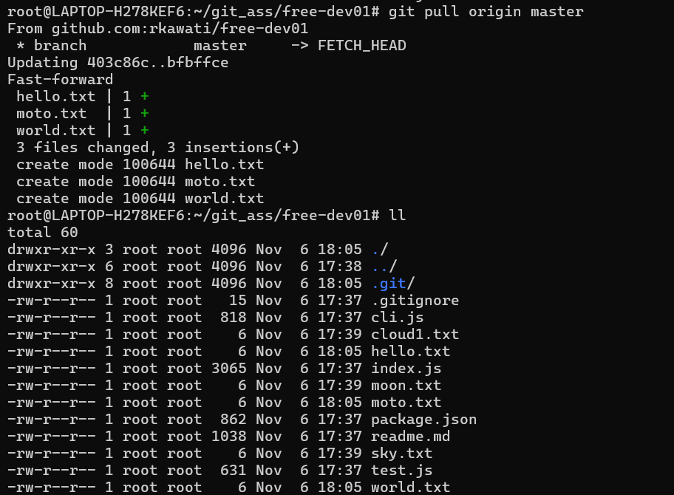

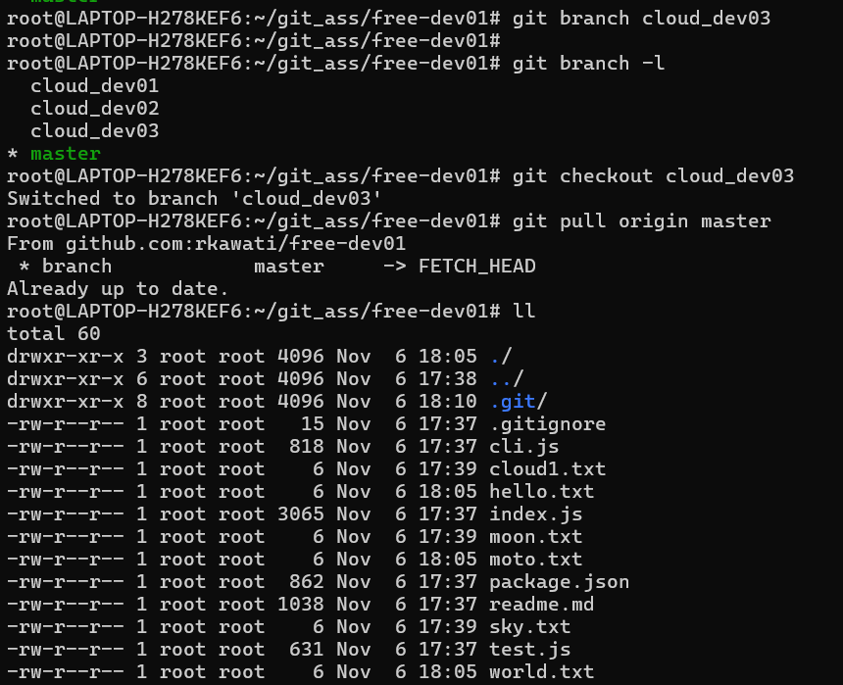

==================================================================================

7. Checkout to the cloud_dev01 branch locally and rebase the remote master

branch of the forked repository.

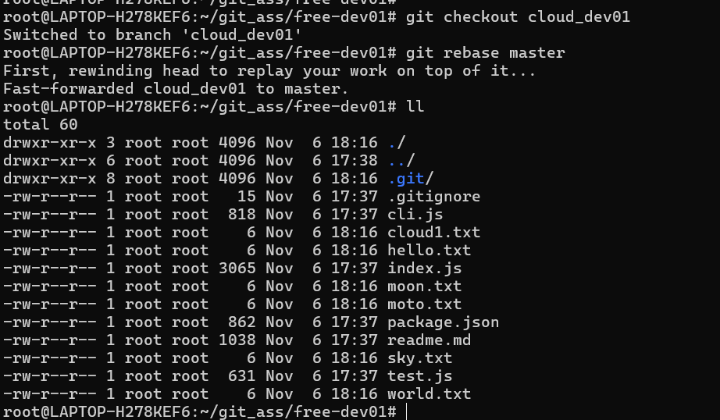

==================================================================================

8. Create one repository locally. Commit any 3 files to the local repository. And the

revert back the commits.



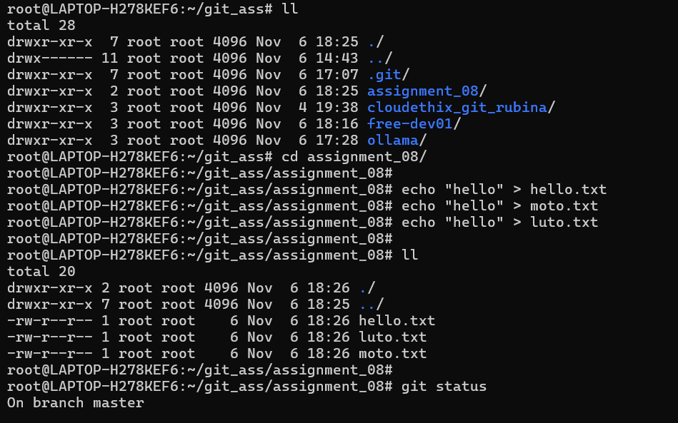

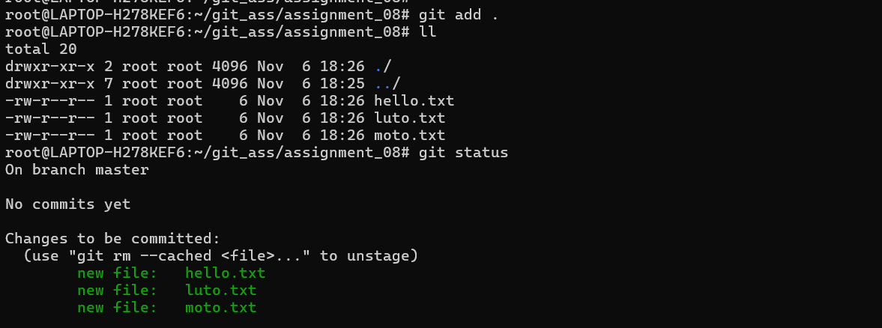

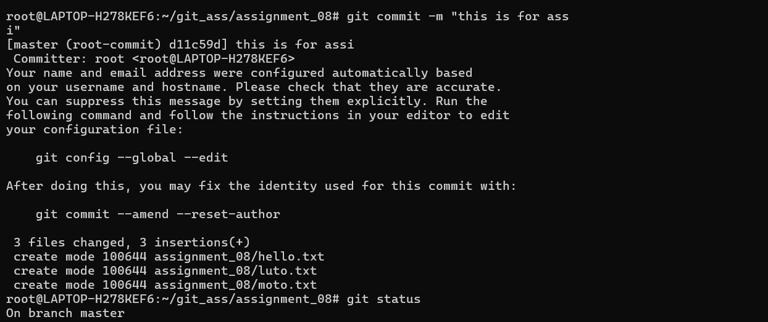

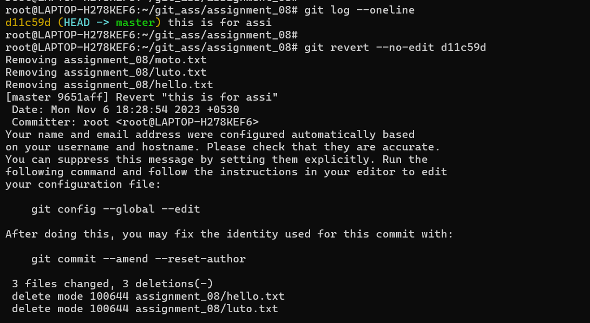

9. Create one local repository. commit some files to the local master branch.

Checkout to master_02 branch. Create 2 more files. Add those to the staging

area. Create stash area and those files. Then list and delete the stash.

Solution==

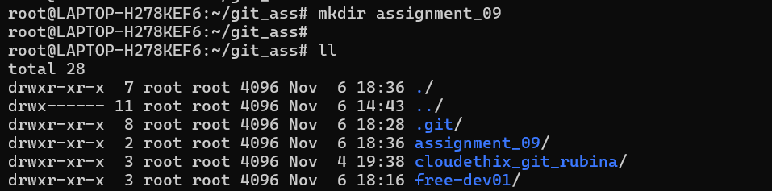

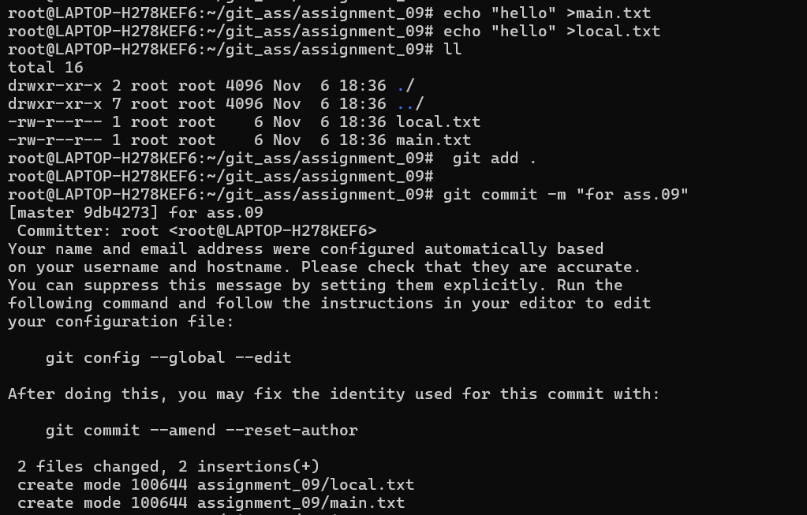

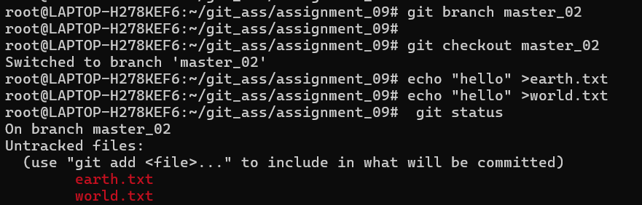

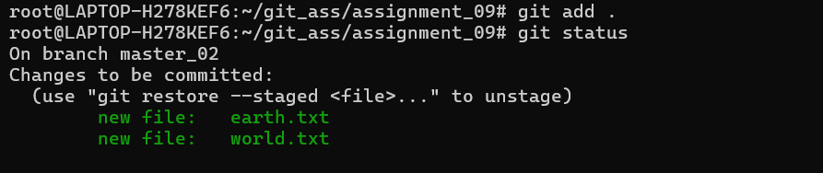

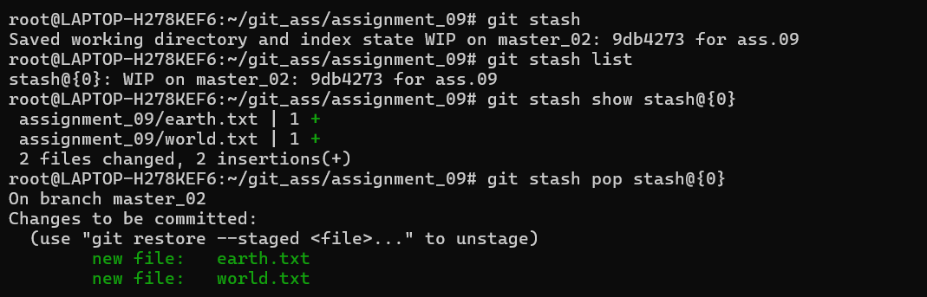

==================================================================================

10.Create a local repository, initialise it and create 3 branches: develop, hotfix and

release. Checkout to hotfix branch and commit cloudethix.txt and once

committed amend the commit message.

